Community Council Report

Llandow Ward

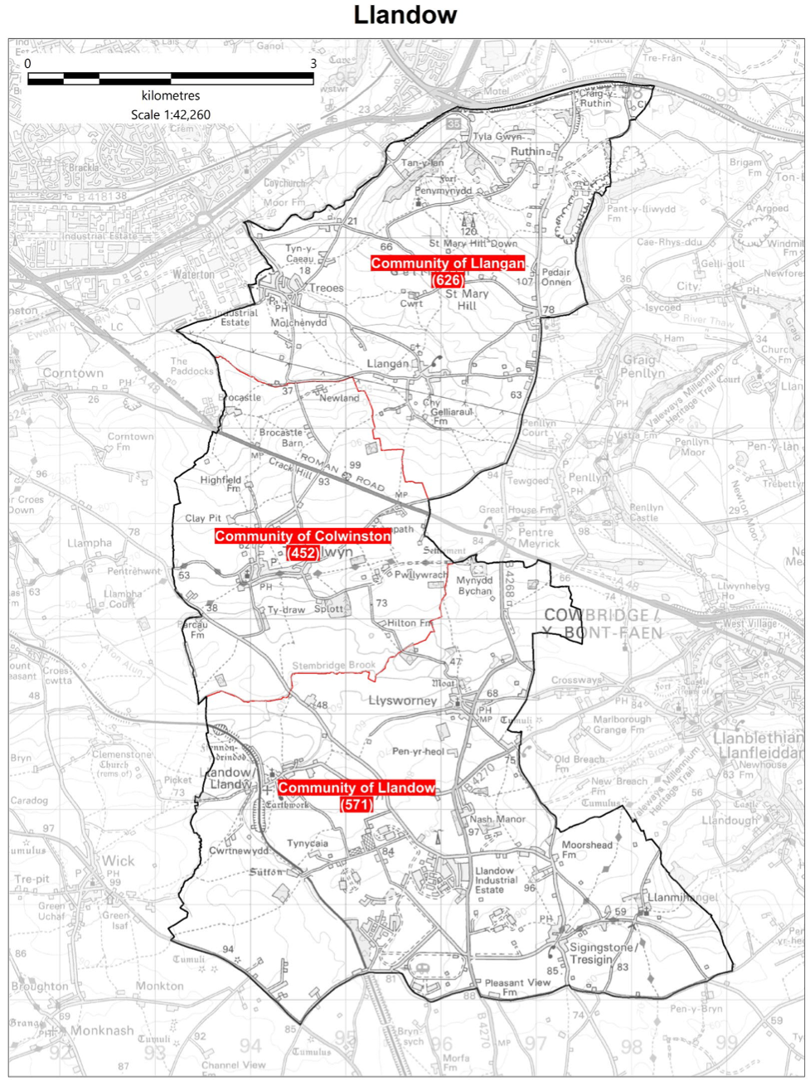

Cllr. Christine Cave email: cacave@valeofglamorgan.gov.uk

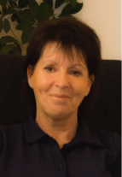

**Date: January 2025** Report to the Community Councils (CC) in the Llandow Ward: Colwinston; Llandow, Llysworney, Sigingstone, Sutton and Llangan/Treoes and St Mary Hill.

**Vale of Glamorgan Full Council meeting date to April 2025**

13th January (Special x 3) 2025

3rd March, 2025

28th April, 2025

**Full Council meeting 2nd December 2024**

Minutes can be found here:

<https://www.valeofglamorgan.gov.uk/Documents/_Committee%20Reports/Council/2024/24-12-02/Minutes-and-DN.pdf>

**Members of the Vale of Glamorgan Council Cabinet**

Councillor L. Burnett (Executive Leader and Cabinet Member for Performance and Resources) – **Labour Party**

Councillor B.E. Brooks (Deputy Leader and Cabinet Member for Sustainable Places) – **Labour Party**

Councillor R.M. Birch (Cabinet Member for Education, Arts and the Welsh Language) – **Labour Party**

Councillor M.R. Wilson (Cabinet Member for Neighbourhood and Building Services) **Labour Party**

Councillor M.R. Wilkinson (Cabinet Member for Public Sector Housing and Tenant Engagement) **Labour Party**

Councillor E. Williams (Cabinet Member for Social Care and Health) **Llantwit First Party**

Councillor S. Sivagnanam (Cabinet Member for Community Engagement, Equalities and Regulatory Services) **Labour Party**

Councillor G. John (Cabinet Member for Leisure, Sport and Well-being) **Llantwit First Party**

**Cabinet meetings for January 2025**

9th January and the 16th January 2025

**Current consultations**

**Strategic Equality Plan for 2025-2029 consultation**

<https://participate.valeofglamorgan.gov.uk/help-shape-our-strategic-equality-plan-for-2025-2029-2>

**[Placemaking](https://participate.valeofglamorgan.gov.uk/placemaking" \t "_self)**

[Welcome to our Placemaking hub, a platform for you to share your views on how to improve our town...](https://participate.valeofglamorgan.gov.uk/placemaking" \t "_self)

[View Project](https://participate.valeofglamorgan.gov.uk/placemaking" \t "_self)

**Draft Annual Self-Assessment 2023 - 2024**

Make a comment on the Draft Annual Self-Assessment

View Project

**[Draft Corporate Plan 2025 - 2030](https://participate.valeofglamorgan.gov.uk/corporate-plan-2025-2030" \t "_blank)**

[The Draft Corporate Plan 2025 - 2030 sets an ambitious programme of work to deliver the Council’s...](https://participate.valeofglamorgan.gov.uk/corporate-plan-2025-2030" \t "_blank)

[View Project](https://participate.valeofglamorgan.gov.uk/corporate-plan-2025-2030" \t "_blank)

**Local Matters**

## Colwinston/Llangan/Llandow – Local Democracy Boundary Commission review of Town and Community Councils– letter of objection sent – press briefed on issue – response from the minister has not yet been received – ongoing

## Colwinston – Adoption of the vines– ongoing

* Colwinston – Village Hall roof repairs and possible transfer of assets – questions around costings raised at full council – see: <https://www.youtube.com/watch?v=yC1iea5tSdk> questions section. - ongoing
* Colwinston – Speed limit requested in the area of the Old Ford – VoG rejected request - ongoing
* Colwinston – Old ford – signage – request made to VoG for advice - ongoing
* Colwinston – Coffin Sile – appeal dismissed, and applicant required to reinstate - ongoing
* Colwinston – Section 106 money – “Thankful Village” Benches – completed
* Colwinston – Request for VoG to clean the pond – ongoing.
* Colwinston – Matters raised regarding the LDP, the Planning webpage contains a link to the RLDP and the relevant documents/stages so far, and it contains this statement. *The inclusion of a site in the Candidate Site Register does not infer that it will be allocated within the emerging RLDP, nor does it imply any preference of the Local Planning Authority regarding its merits. This register is not a public consultation document; merely a statement of fact of all the candidate sites which have been submitted at this stage.* Link below: <https://www.valeofglamorgan.gov.uk/en/living/planning_and_building_control/Planning/planning_policy/RLDP/Candidate-Sites.aspx>
* Colwinston – Drainage issue – raised with VoG - ongoing
* Llandow – Glue Pot Bridge – work on flooding issue undertaken by VoG highways department – issues with the standard of work have been raised and there will be further work undertaken in January - ongoing
* Llandow – Field run off – Following on from meeting held in October with NRW, request made to VoGC to clear drains in Grove Road. Topographical survey provided to Llandow Action Group members – meeting to be arranged for February 2025 - ongoing
* Llandow – Fly tipping cases were reported to the VoG and actioned. A camera has now been located on the Llandow Industrial Estate – ongoing
* Llandow – Overgrown hedgerow by the cross roads as you enter Llandow – VoG officers have scheduled an inspection and identification of landowner - ongoing
* Llandow – Poor state of the play area in Llandow meeting to take place in January with VoG officer to look at Llandow CC members undertaking funding application for play equipment- ongoing
* Llandow – Potholes reported – ongoing
* Llangan – Speeding traffic is an ongoing issue – potential action to be discussed at next CC meeting - ongoing
* Llangan/Colwinston/Llandow issues raised with Rob Thomas regarding the re-banding of homes in the ward – ongoing
* Llangan/Colwinston/Llandow – Issues raised by members of the public in Treoes regarding GreenLinks Service – ongoing
* Llangan – Planning matters raised with VoG regarding Solar Development Court Farm - ongoing

**Local items reported in the press –**

The GreenLinks bus Service

[***https://penarthnews.wpcomstaging.com/2024/11/30/vale-councils-greenlinks-bus-service-sent-huge-invoices-to-pensioners/***](https://penarthnews.wpcomstaging.com/2024/11/30/vale-councils-greenlinks-bus-service-sent-huge-invoices-to-pensioners/)

[***https://www.walesonline.co.uk/news/wales-news/people-relying-council-transport-left-30574031***](https://www.walesonline.co.uk/news/wales-news/people-relying-council-transport-left-30574031)

[***https://welshwave.co.uk/single.php?id=791340***](https://welshwave.co.uk/single.php?id=791340)

Scheduled Meetings for January 2025 - All Meetings commence at 6.00 p.m. and will be held virtually unless otherwise stated

|  |  |  |  |
| --- | --- | --- | --- |
| Council | 13 Jan  (Special x 3) | Early Retirement/Redundancy (4.00 p.m.) |  |
| Annual Meeting |  | Licensing - Public Protection  (10.00 a.m.) | 21 Jan |
| Cabinet (2.00 p.m.) | 9 Jan;  16 Jan | Licensing - Statutory |  |
| Scrutiny (Corporate Performance and Resources) | 15 Jan | Licensing Sub (10.00 a.m.) |  |
| Scrutiny (Environment and Regeneration) | 14 Jan | Planning (4.00 p.m.) | 16 Jan |
| Scrutiny (Healthy Living and Social Care)  (5.00 p.m.) | [7 Jan](https://www.valeofglamorgan.gov.uk/en/our_council/Council-Structure/minutes,_agendas_and_reports/agendas/Scrutiny-HLSC/2025/25-01-07.aspx) | Public Rights of Way (10.00 a.m.) | 22 Jan |
| Scrutiny (Homes and Safe Communities) | [8 Jan](https://www.valeofglamorgan.gov.uk/en/our_council/Council-Structure/minutes,_agendas_and_reports/agendas/Scrutiny-HSC/2025/25-01-08.aspx) | Senior Management Appointment |  |
| Scrutiny (Learning and Culture) | [6 Jan](https://www.valeofglamorgan.gov.uk/en/our_council/Council-Structure/minutes,_agendas_and_reports/agendas/Scrutiny-LC/2025/25-01-06.aspx) | Standards (10.00 a.m.) | 30 Jan |
| Appeals |  | Trust |  |
| Goverance and Audit (2.00 p.m.) | 6 Jan | Vale of Glamorgan Local Access Forum |  |
| Community Liaison | 28 Jan  30 Jan | Voluntary Sector Joint Liaison | 27 Jan |
| Democratic Services (4.00 p.m.) |  | Welsh Church Act Estate (4.00 p.m.) | 20 Jan |
| Investigating |  | Shared Regulatory Services Joint Committee |  |